Want to write a book? Alice Campion explains.

So what happens when four members of a bookclub want to write a book? Instead of writing four separate works, they decided to work together, challenging themselves to write a ‘21st Century Thorn Birds’ type novel and created ‘Alice’ in the process.

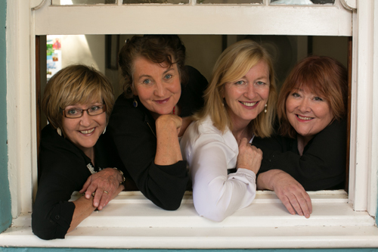The Alice Campions (aka Jenny Crocker, Jane Richards, Jane St Vincent Welch and Denise Tart) have all been profoundly shaped by their knowledge and experience of working and living in rural NSW.

Alice Campion's The Painted Sky and The Shifting Light have both been hailed for their strong sense of place. Both books are set near Bourke in far west NSW, an area the writers visited as part of a fact-finding trip when they were writing The Painted Sky.

It was on this second trip out west that ''the Alices'' met women from remote stations who had driven for hours to attend a talk. They had been inspired by the story of writing a book collaboratively and they were in the process of starting such a project themselves with women from ''neighbouring'' properties (hundreds of kilometres away from each other), using email to write.

Their second book, The Shifting Light will be released by Penguin Books on the 28th February, just before the Jugiong Writers’ Festival, and is a great opportunity for any budding authors, or people wanting to write collaboratively, to come and listen and chat on the 18th March with these four remarkable women about their journey to being published.

There is something for everyone at this year’s Festival. For more information visit www.jugiongwritersfestival.com.au

10th – 19th March 2017

It’s on again! This year’s Biennial Jugiong Writers Festival will play host to an incredible array of writers, illustrators, artisans and readers for a second time.

The 2015 Festival had visitors travelling from Canberra, Wagga and the region for a fun filled weekend, and with more on offer, the volunteer committee are excited about this year’s festival.

Beginning on the 10th March, the GMP Small Schools Day will run five workshops at Jugiong Public School encouraging creative, writing, illustrating, cartooning and reading for approximately 110 students from small schools in the area.

Continuing on to the 18th, the Jugiong Hall will play host to some of Australia’s top writers in a day filled with conversation and entertainment, something for everyone ranging from the hugely popular Di Morrissey, author of over 25 Australian bestselling works, through to Stan Grant and Professor Bill Gammage, to name but three.

Jugiong Park will host a delicious gourmet brunch, live entertainment, artisan markets and announcement of the short story and poetry competitions on the Sunday.

There is something for everyone at this year’s Festival. For more information visit www.jugiongwritersfestival.com.au

